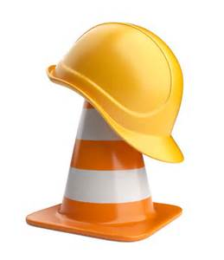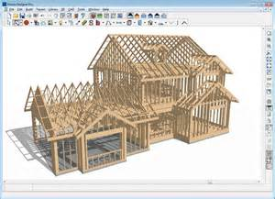
Starting on August 7, 2018 Eva’s Phoenix is going to be bustling with a lot of construction sounds. We find the hard hat, a tool belt and getting our hands dirty very exciting….. If you know of youth who do as well, then tell them about our
Construction and Building Maintenance Training Program
Over a period of 8 weeks our highly qualified instructors will help guide and prepare 10 youth to be the future champions of this sector. The list of takeaways is pretty incredible to say the least as the youth will walk away with comprehensive introductory training in:
ROUGH & FINISH CARPENTRY DRYWALL / TAPING / MUDDING  WINDOW & DOOR INSTALLATION  BASIC ELECTRICAL & PLUMBING  PAINTING/ FLOORING / TILING | HEALTH & SAFETY TRAINING  WHMIS  WORKING AT HEIGHTS CARD  BLUEPRINT READING  RESUME / INTERVIEW SKILLS

And even more opportunities to further build on these skills through:
- $100 PER WEEK STIPEND AND CONSTRUCTION TOOLKIT incl. hardhat and safety boots

Our goal is to get youth REAL JOBS in a high demand skilled trade where work force shortage is a reality.
Training at Eva’s Phoenix : Tues , Wed , Thurs & Fri. 8:30 AM to 2:30 PM
So if you know of youth between 16-24 years of age, help them download the application form at www.evasinitiatives.ca . They can e mail to: dbedini@evas.ca or fax: 416- 364 -2985
DIRECTIONS: We are located @ 60 Brant St. NW corner of Brant and Richmond

