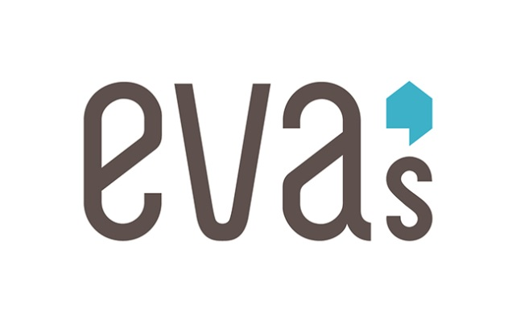
EVA’S CONSTRUCTION AND BUILDING MAINTENANCE TRAINING PROGRAM APPLICATION FORM
60 Brant Street (Corner of Brant & Richmond) Toronto, ON M5V 3G9
Telephone: (416) 364-4716 ext 259

We know you are awesome. Let us add one more feather to your cap!

We are offering an 8 week training program in the field of construction and building maintenance. Our instructors, training partners and employer network are here to support you in your journey to a fulltime career in the construction or building maintenance fields. Here are just a few of the things we are offering:

- Hands on training in Framing and Rough Carpentry, Drywall installation and Finishing, Window and Door Installation, Flooring, Tile Installation , Painting, Basic Electrical and Plumbing
- Health and Safety training, WHMIS Certification, Working @ Heights Certification and Certificate of Completion to be added to your resume !
- Resume building
- Construction technology tool kit including hardhat and safety boots
- $100 per week stipend

In return we ask for a few things:

- You are between 16 and 24 years old
- Interest in a career in the field of Construction or Building Maintenance
- Legally allowed to work in Canada
- Attendance and availability starting August 7,2018 for 8 weeks on :

  - Tuesdays – 8:30 AM – 2:30 PM
  - Wednesdays – 8:30 AM – 2:30 PM
  - Thursdays – 8:30 AM – 2:30 PM
  - Fridays – 8:30 AM – 2:30 PM

NOTE: Class days may be subject to change

For any queries, please feel free to contact Dave Bedini at 416 364 4716 ext. 259.

WAYS TO APPLY:

- E mail : dbedini@evas.ca or fax: 416 364 2985

Please fill out the following form…..Honest answers to the following questions will help us provide better support and will not be detrimental to be considered for the program.

- Name: _______________________________________________________

- Contact Number: _________ ___________ ______________________________

- E mail _______________________________________________________

- Your current address: __________________________________________________

__________________________________________________

- Birth Date : ____________ _____________ __________________
Month Day Year

- Are you available to attend the training on the above mentioned dates? YES NO

- Are you currently employed? (including part time ) YES NO

- If ticked yes in question 7, is this part time work? YES NO

- Are you currently a Social Assistance recipient? YES NO

- Does your SIN # start with “9”? YES NO

- Are you legally allowed to work in Canada? YES NO

- Do you have any or have been diagnosed with mental health concerns? YES NO

________________________________________________________________

- Are you currently on any medication? YES NO

If you answered yes to question 12, please list down the medicine names, otherwise write NA:

  - _______________________________________________________________
  - _______________________________________________________________
  - ________________________________________________________________

- Do you have any substance use concerns? YES NO

________________________________________________________________________________________

- If you answered yes to either question 12 or question 14, are you working with any support? If so, with who?

Name of the support person: ______________________________________________
Contact Number: __________ ____________ ______________________
Agency/Institution Details:

- Did you successfully complete Grade 10th math? YES NO
- If the answer to the above question is no, until what grade did you study math? _____________

- Is reading instructions or warning labels a challenge for you? ___________________________

__________________________________________________________________________________

- Do you have any prior experience on a construction site? YES NO

- We all have our weaknesses and difficulties. Please tell us which one(s) could hinder you from being successful in this training (please tick whatever are applicable)

- What interests you to join the building maintenance and construction training program?

- What are some things you hope that would not be a part of this training? In other words what would you not like to see/experience in this program?
________________________________________________________________________________________________________________________________________________________________________________________________________________________________________________________________________________________________________________________________________________________________

- Please list down the name and contact details of the agencies/primary workers that have worked or are working with you (please specify if this is a past or present relationship):
________________________________________________________________________________________________________________________________________________________________________________________________________________________________________________________________________________________________________________________________________________________________

- If you have a resume we would love to receive it. Are you attaching your resume with this application?

- If this form is being completed by a representative or support worker, would you like to make any additional comments relating to the youth’s application/candidacy?
__________________________________________________________________________________________________________________________________________________________________________________________________________________________________________________________________________________________________________________________________________________________________________________________________________________________

- What is your current housing status? ________________________________________________________________________________________________________________________________________________________________________________________________________________________________________________________________________________________________________________________________________

- How did you hear about this program? (please include name of the agency/website/reference) ____________________________________________________________________________________________________________________________________________________________________________________________________________________________________________________________________________________________________________________________________________________________________________________________________________________________________________________________________________________________________________

Thank you for your application.

